|  |
| --- |
| EPAM Systems, RD Dep., RD Dep. |
| MTN.*NIX.11 Automated Environment Configuration Management  **Ansible. 2** |

|  |  |  |  |  |  |
| --- | --- | --- | --- | --- | --- |
| REVISION HISTORY | | | | | |
| Ver. | Description of Change | Author | Date | Approved | |
| Name | Effective Date |
| <1.0> | Initial revision | Siarhei Beliakou | 17-Mar-2017 |  |  |
|  |  |  |  |  |  |

# Lab Work Task. Web Server Provisioning

# Review

Using Ansible v2.2.1 for provisioning nginx + tomcat application stack.

Learning by doing.

# Task

On Host Node (Control Machine):

1. Create folder ~/cm/ansible/day-2. All working files are supposed to be placed right there.
2. Spin up clear CentOS6 VM using vagrant (repo with vagrantfile). Verify connectivity to the host using ssh keys (user: vagrant)
3. Create ansible inventory file (name: **inventory**) with remote host connection details:

* Remote VM hostname/ip/port
* Remote ssh log in username
* Connection type

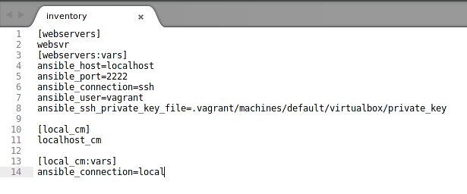

1. Develop a playbook (name: **site.yml**) which is supposed to run against any host (specified in inventory)
   1. Develop roles:

* **java** (installs java)

./roles/java/tasks/main.yml

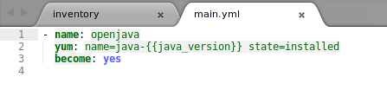

* **java_test** (does only checks that java installed and running properly)

./roles/java_test/tasks/main.yml

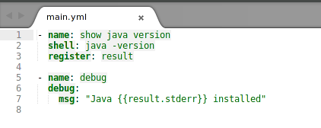

* **tomcat** (installs tomcat)

./roles/tomcat/tasks/main.yml

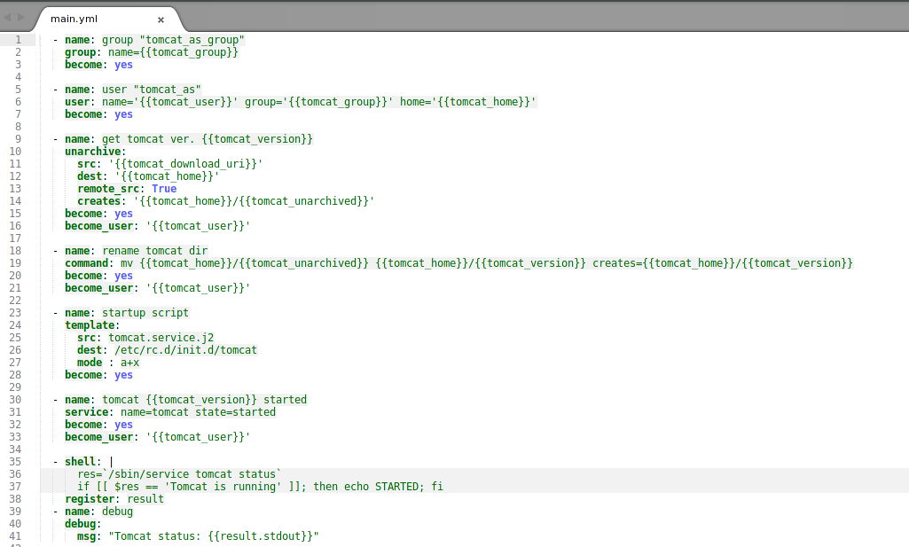

* **tomcat_test** (does only checks that tomcat installed and running properly)

./roles/tomcat_test/tasks/main.yml

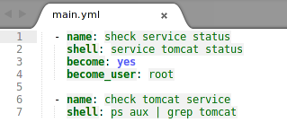

* **nginx** (installs nginx)

./roles/nginx/tasks/main.yml

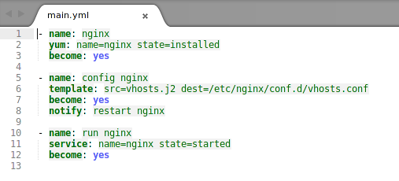

./roles/nginx/templates/vhosts.j2

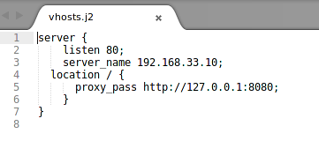

* **nginx_test** (does only checks that nginx installed and running properly)

./roles/nginx_test/tasks/main.yml

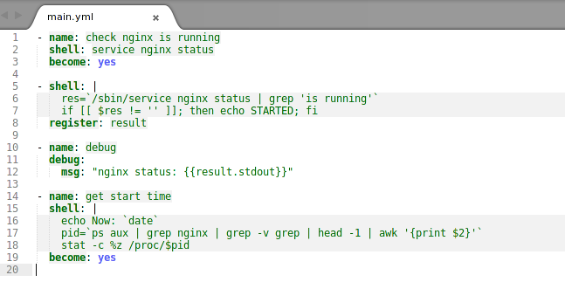

* 1. Playbook should consist of **2** Plays:
* Installation
* Verification

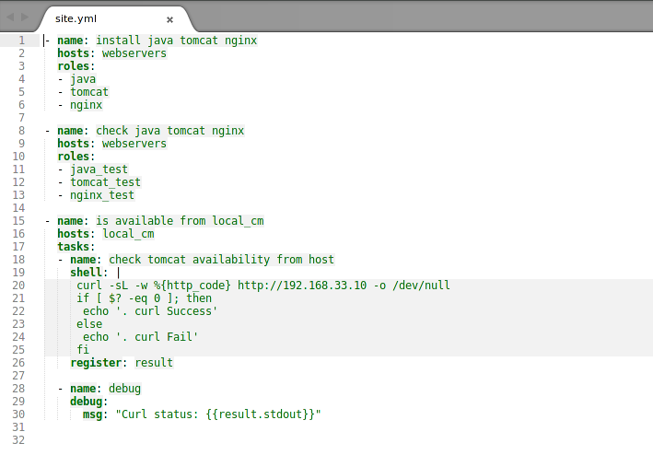

* 1. Use **handlers** to manage tomcat/nginx configuration changes

./roles/nginx/handlers/main.yml

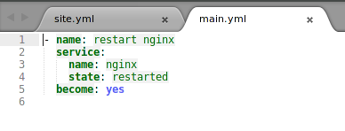

* 1. Use module **debug** to check configuration during the installation
  2. Define play/roles variables (at least):
* **tomcat_version**
* **tomcat_home**
* **tomcat_user**
* **tomcat_group**

./roles/tomcat/vars/main.yml

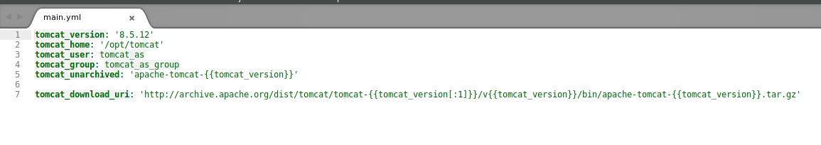

* **java_version**

./roles/java/vars/main.yml

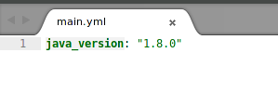

* 1. Every task/handler should have a name section with details of task purpose.

1. Software installation requirements:

* Tomcat AS should be installed from sources (tar.gz) – download from the official site (<http://archive.apache.org/dist/tomcat/>).
* Tomcat AS should be owned (and run) by user specified in variable (default: tomcat_as:tomcat_as_group).
* Tomcat AS version should be 7.x, 8.x (at least 5 versions), exact version to be installed is taken from appropriate variable.
* Tomcat installation folder (CATALINA_HOME) is /opt/tomcat/**$version**, where **$version** is the version of tomcat defined in playbook.
* Java can be installed from CentOS Repositories
* Use module **yum** to install Nginx
* Use module **template** for management of nginx cofigs
* Tomcat home page should be available on port 80 (accessible from Control Machile) via nginx.

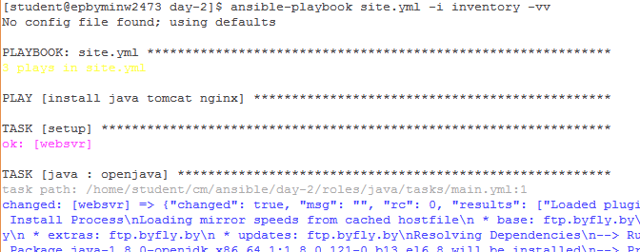

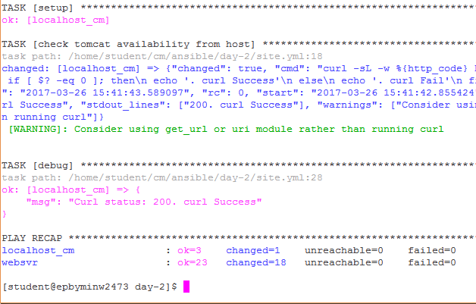

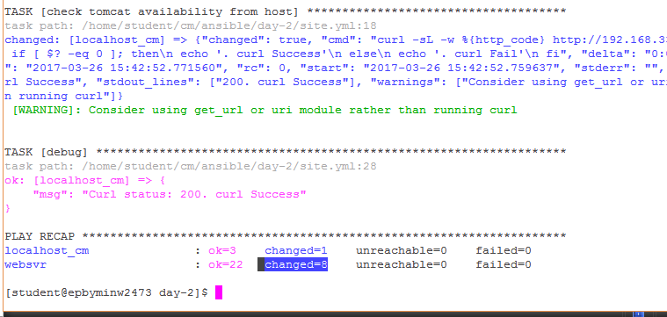

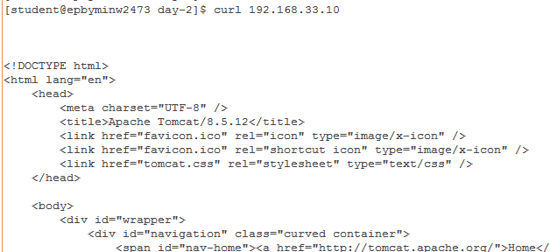

1. Verification Procedure: playbook will be checked by instructor’s CI system as follows:
   1. Connect to student’s host by ssh (username “student”) with own ssh key.
   2. Go into the folder mentioned in point 1
   3. Destroy/Launch VM: vagrant destroy && vagrant up
   4. Execute VM provisioning: ls ansible-playbook site.yml -i inventory -vv
   5. If previous steps are done successfully, instructor will check report (pdf-file)
2. Feedback: report issues/problems you had during the development of playbook and time spent for development.